Gravimetric Survey in the VIDAL quadrangle, continued

Field Camp 2005

Vivian Leung, William McGehee, Shelsea Pedersen, Adele Schwab, Shaye Storm

Abstract
The primary objective of the study was to develop a subsurface map of the area being surveyed using gravity measurements taken at distinct points throughout the region. The location of the survey was the same as the previous year. Last years data was therefore taken into consideration when deciding where to take measurements this year. The gravity data was interpreted with the surface geology in mind. The region contained faults and various rock formations. Gravity measurements were taken every 200-300 meters to cover all the area needed for a better understanding of the region and its subsurface formations. In order to determine the density of the alluvium which covered a substantial portion of the geology of the region, gravity measurements were taken at the edge of a wash at two distinct elevations. The gravity measurements were also used with the purpose of improving last year’s geology map. Once all of the field work was completed the MATLAB scripts from previous years were cleaned up and organized for a more logical flow of corrections. Due to new restrictions on airplane cargo, the gravimeter had less than ideal time to warm up before being taken out for measurements. A warm up test was performed back at MIT to get a preliminary understanding of the effect of temperature on the gravimeter readings.
I. Introduction
Method
The main objective of the field study was to develop a subsurface map of the region being studied. The means by which this was accomplished were analyzing slight changes in gravity across the region using the highly sensitive LaCoste and Romberg gravimeter. In the effort to understand the subsurface structures of an area based on surface gravity measurements, one would wish to take all their measurements in exactly the same manner and at exactly the same time so that any trends found in data would be due to actual subsurface structures, not one of the many predictable aberrations in local gravity that exist. Since this is not possible, one must be concerned about the effects these aberrations have on data including the natural drift in the precision of our mechanical gravimeter, tidal influences, elevation changes, effects of varied terrain, and the effects of the earth’s latitude dependent oblateness as they are described in following sections.
Location at Base Camp and Local Geology
Latitude - 34.062513490 °N
Longitude - 245.455947957 °W
Ellipsoidal Height - 234.5261 (m)
Geoidal Height - -31.5 (m)
The Riverside Mountains are composed of four main groups of rocks. The oldest are Precambrian rocks at the north of the mountains. These contain a metaigneous unit including augengneiss, leucogranite, and granite with quartz veins as well as a metasedimentary unit including biotite schist, quartzite, and gneiss. Much of the Precambrian is mylonitic and contains folds ranging from the centimeter to meter scale. Outcrops usually have a dark orange-brown desert varnish tinged with maroon. The next oldest are Paleozoic rocks from part of the Grand Canyon sequence, including the Permian Supai formation, Mississippian Redwall, Devonian Temple Butte, Cambrian Upper Muav and Cambrian Lower Muav. These are limestones and dolomites which have been partially metamorphosed into marbles. At the south of the range, and partially at the east, there are rocks of Mesozoic age. These include metagranite, calcareous schist, a magmatic suite containing porphyry and a weathered granite and the Jurassic Planet Volcanics. Finally to the west of the mountains are Tertiary rocks. These include various sandstones, and conglomerates as well as scattered sections of lake sediments. Many of these rocks are characterized by a dull clay red color that is visible from a distance.
The Tertiary section is mostly defined by two faults. The eastern side is bound by a shallow detachment fault dipping ~10° to the west. The western side is bound by another detachment fault dipping to the east. To the south, the eastern detachment begins to curl northwards. The Tertiary is surrounded by Precambrian rocks at the north and west, Mesozoic rocks at the south, and Paleozoic and Mesozoic at the east. The Paleozoic and Mesozoic are connected through a complex series of faults and overturned faults. That section is separated from the Precambrian by a northeast-southwest thrust fault dipping ~30-40° north. This fault is cut off by the eastern detachment and reappears with metagranite in the hanging wall.

Regional Geology
To the north of the Riverside Mountains are the Basin and Range provinces of Nevada. This is a series of north-south longitudinal mountain ranges separated by expansive basins. They are created by continuing widespread extension causing tilted fault blocks and forming large scale horses and grabens. Closer to the Riverside Mountains, the Colorado River Extensional Corridor carries extensional activity to the south.
The west coast of the United States has been and is an active continental margin due to the complete subduction of the Kula plate, continuing subduction of the Fallon plate and the northward strike-slip motion of the Pacific’s plate relative to the North American plate. The western margin of the North American plate has been growing due to island arcs accreting to the continent.

II. Procedures
Gravimeter
A LaCoste and Romberg gravimeter was used to take the gravity measurements in the field. The design of the gravimeter enables it to detect very slight changes in gravity. A mass is held on the end of a horizontal bar. A spring is attached to the bar at approximately a 45 degree angle. The spring is used to restore the mass to its designated "initial" position. The amount of force needed for the spring to bring the mass back into this position is converted into a gravity reading taken from the dial using a series of levers. The gravimeter is composed of metal parts. This requires that its internal temperature be maintained to prevent thermal contraction or expansion. The gravimeter is therefore completely sealed and its temperature is maintained using a battery powered heater. Mechanical drift due to creep in the metal spring will occur in the gravimeter. This required base camp gravity measurements at the start and finish of each day to be able to account for the drift.
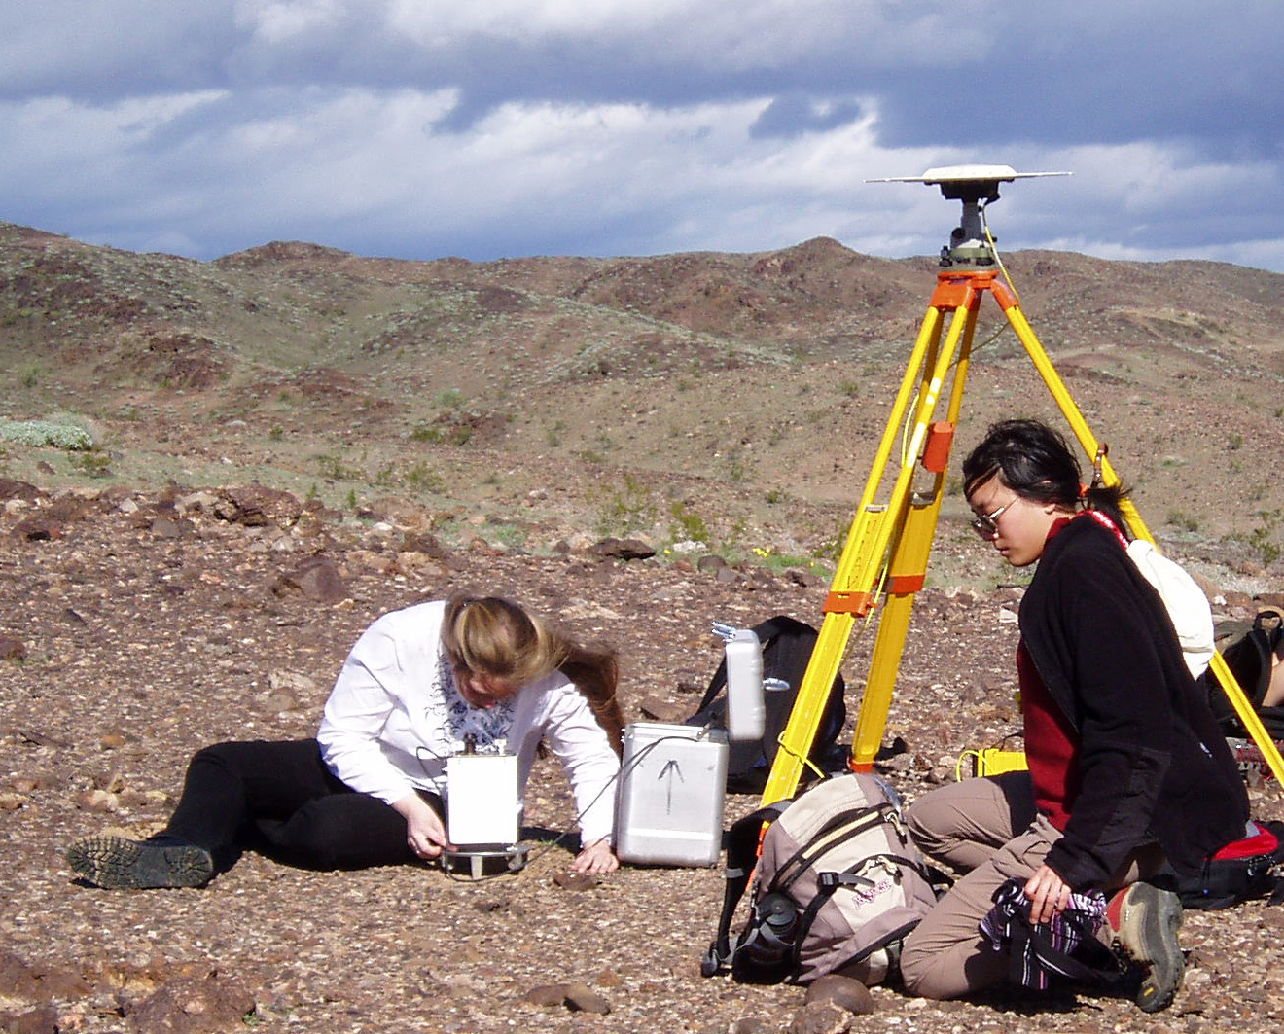
Figure 1: Using the gravimeter in the field

GPS
GPS, Global Positioning System is a satellite-based navigation system put into orbit by the U.S. Department of Defense. Composed of a network of 27 Earth-orbiting satellites in geostationary orbit 12,000 miles above earth, of the 27 satellites, 24 are in use with the other 3 being spares; just in case one fails. Circling the earth twice a day, they transmit signal information to earth, and the GPS receivers take this information and use triangulation to calculate the user's exact location. Essentially, the GPS receiver compares the time a signal was transmitted by a satellite with the time it was received. This time differential tells the GPS receiver how far away the satellite is. Compiling the distance measurements from a few more satellites, the receiver can then determine the user's position and present it on the unit's electronic map.
The fieldwork was executed with several different GPS setups. Throughout the roving fieldwork, both a mobile and static GPS were used; one that was carried throughout the area mounted on a tripod and one at base camp. Through these, the latitude, longitude and elevation of the gravity measurements were recorded; a GPS receiver must be locked on to the signal of at least three satellites to calculate a two-dimensional position (latitude and longitude) and track the movement. However, with four or more satellites in view, the receiver is able to determine the user's three dimensional position (latitude, longitude and altitude). At every location, the antenna would be reasonably leveled to increase precision, and then the height of the tripod antenna would be recorded using a height stick. While the measurements were not exact, that was alright, as it was only necessary to place the gravimeter within a meter or so of the GPS antenna. At each site, the GPS would be put into static mode so that it could take several minutes of measurements. These measurements, averaged over the time it took to make the measurement resulted in an accuracy that compensated for the small uncertainty relating to the displacement of the gravimeter. The two other GPS setups were used less frequently, and were related to seismographic research and to figuring out the location of the team at any given time. The first of these two setups resulted in the most precise measurements taken throughout the course and were measured over the course of eight hours between two GPS tripod antennas no more than a half-mile apart. The GPS antennas were aligned with geodetic markers in the ground through an attached telescope with crosshairs. The height was then measured with the height stick and the antenna was aligned relative to true north. The second of these setups was simply a hand-held GPS receiver that relayed the team’s position at all times and allowed for them to locate themselves during the fieldwork. This gave them the ability to record their latitude and longitude at each position and measurement which was an essential part of the later data analysis.
Coordinate Systems
While spherical in nature, the Earth is constantly distorted due to the centrifugal force of daily rotation, resulting in a shape more akin to an oblate ellipsoid. The distance between the Earth’s poles and its equator varies by about 20 kilometers at any given time due to this force. It is because of this that spherical coordinates, while seemingly obvious at first, would not be as helpful as one may initially believe, and as a result there have been several ellipsoidal coordinate systems devised. The three most common coordinate systems still in use today include NAD27, NAD83 and WGS84; the final two digits of each system represent the year in which they were first established. WGS84 was found to be particularly well fit for GPS, and was what the team used as their coordinate system this year. The only other relevant coordinate system used was NAD27, which is quite useful when using digital or flat two dimensional maps of the Earth.

Planning of Measurement Point
Two types of gravity measurements were taken in the field. The first day was devoted to taking readings along the road at permanent geodetic markers. The succeeding days of field work were mainly devoted to trekking new terrain to gain a more detailed subsurface map than achieved the previous year. The distance between data points were aimed to be 200 meters. After the first day of hiking and a meeting with the geology field camp, it was decided to spend the next two days exploring the area to the south and southeast to locate the pattern of a fault and determine the presence of a basin.

III. Corrections
Drift
The drift of the gravimeter is hardly perceptible over the time span of
a year, so its influence on our gravity measurements is insignificant.
Thus there is no reason to calculate it for our degree of precision. If
the drift correction were significant, however, it would be performed
after the tidal correction as follows.

$g\text{driftcorrected}=g\text{dial}+((g\text{morning}−g\text{evening})/(t\text{morning}−t\text{evening}))×(t−t\text{morning})$

Conversion
The gravimeter was calibrated after manufacture. The table accompanying the gravimeter was used to determine the conversion factor between the dial reading, and its value in milligals.

Day-to-Day Base Camp Correction
After drift and tidal corrections have been taken into account, the base camp measurements at the start and finish of each day should be the same. A day-to-day correction was therefore needed.

$$g\text{daycorrected}=g\text{driftcorrected}+g1\text{stmorning}−g\text{nthmorning}$$
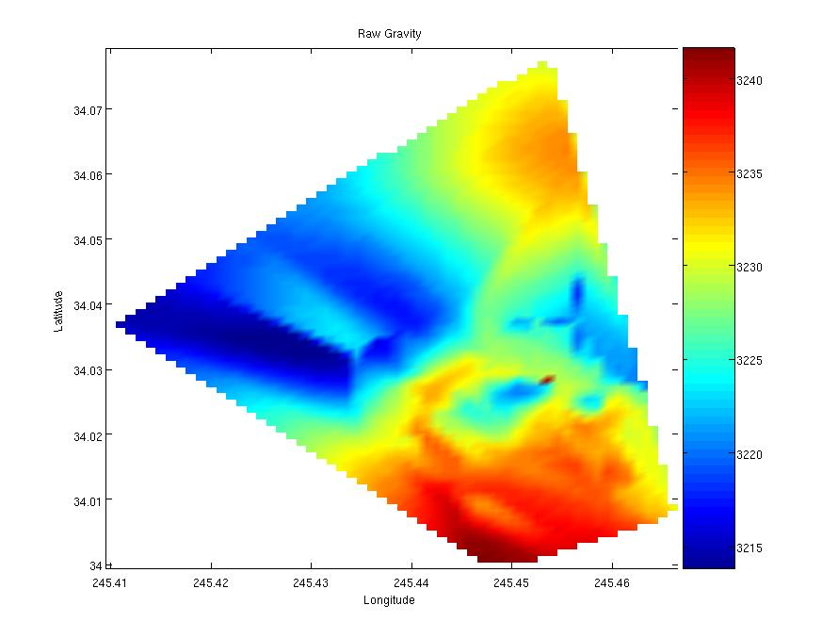
Figure 3: Raw gravity
Tidal
The tidal correction is small, but it is much larger than the drift so therefore must be accounted for first. The tidal forces on earth due to the moon and the sun vary throughout the day and influence the gravimeter readings. The orbits of the sun and the moon cause the surface of the Earth to reshape slightly. This alteration in the position of the Earth's mass causes an increase in gravity at high tide and a decrease in gravity at low tide. Because the effect is most significant in large bodies of water, the effect of tides on gravity measurements is much more pronounced near the oceans. The Riverside Mountains are sufficiently far inland that the tides alter gravity measurements by less than .5 milligals. The forces for each time of measurement were determined using ETGTAB and subtracted out.
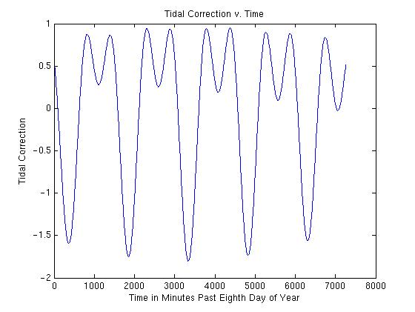
Figure 4: Tidal Correction
Extreme peaks are the effect of the moon, whose gravity is less than that of the sun but whose orbit is closer; middle peaks are the effect of the sun. The effect of the sun is about 50% that of the moon.
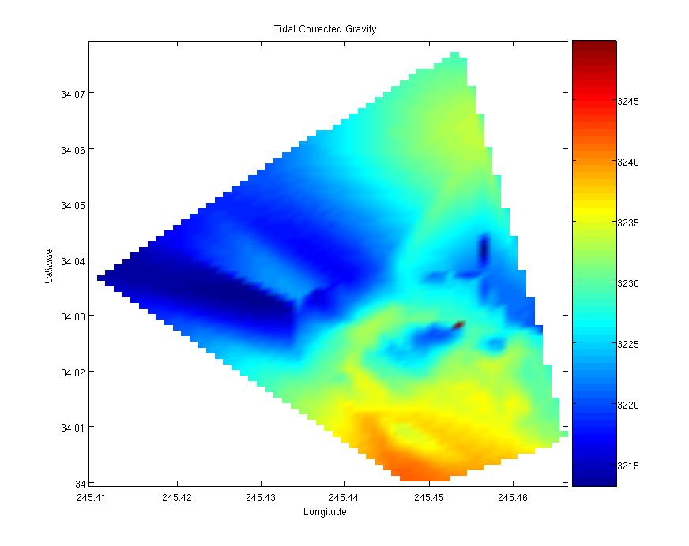
Figure 5: Tidal corrected gravity

Latitude
As the Earth is an oblate spheroid with more mass centered about the equator than the poles, local gravity varies as a function of latitude. One would think that gravity would be greater near the equator since there is more mass directly below the point of measurement. But as gravity is an inverse square relation from the center of mass, the density of the earth is not enough to make up for the greater distance (squared) at the equator from the centroid as compared that of the poles. Hence local gravity increases as latitude increases, and is governed by the below equation:
$$g\text{raw}=\text{978032}×(1+5\text{.}\text{2789}⋅\text{10}\hat{−3}\text{sin}(γ)\hat{2}−2\text{.}\text{35}⋅\text{10}\hat{−6}\text{sin}(γ)\hat{4})$$
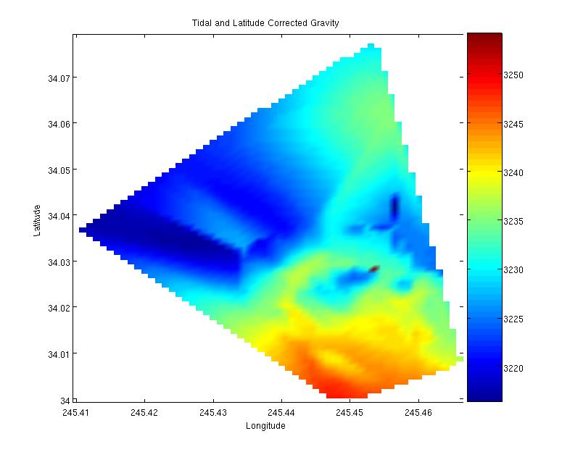
Figure 6: Latitude corrected gravity
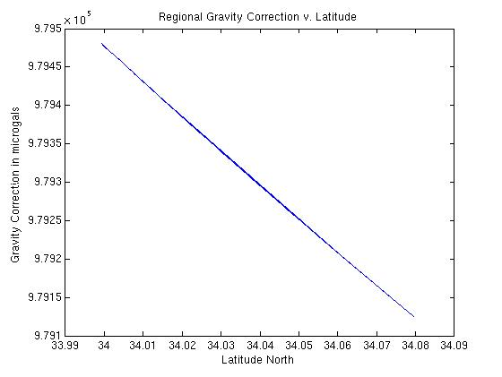
Figure 7: Local latitude correction
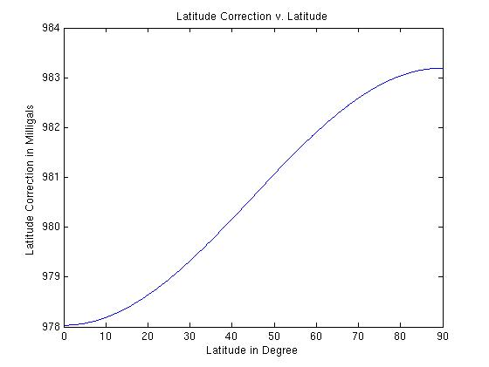
Figure 8: Global Latitude Correction
The Bouguer and Free Air Corrections
The effect of the mountains and canyons on the gravity measurements must be subtracted out in order to determine the underlying surface features. This is accomplished in part by the application of the Free Air and Bouguer corrections.
Free-Air Correction:
The Free Air correction accounts for differences in elevation. The height of the gravimeter was calculated using GPS for each gravity measurement in the field. This was to eliminate elevation as a factor affecting the gravity recorded. Increase in elevation brings the gravimeter further from the earth’s center of mass, and thus produces a decrease in recorded gravity. The same idea holds for decreasing elevation. Since gravity is inversely proportional to the square of the distance from the center of mass of an object, higher elevations have
lower gravity.
$$g\text{free}−\text{air}=g\text{raw}−0\text{.}\text{307}{\text{mgal}}/m×h$$
NOTE: elevation=height as measured by GPS with respect to base camp
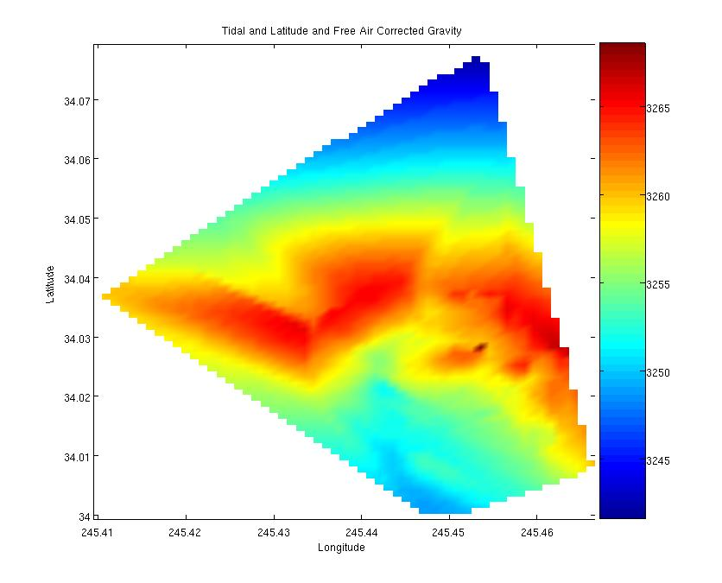
Figure 9: Free-air corrected gravity
Bouguer Correction:
The Bouguer correction allows us to remove the effect of the mass contained in the mountains on our gravity measurements.

$$g\text{bouger}=g\text{free}−\text{air}+2\text{πρ}\text{Gh}$$

The derivation is as follows:
$\begin{aligned}\text{dm}=2π\text{rdr}σ \\ {\text{Ghdm}}/(r^{2}+h^{2})^{3/2} \\ \int_{0}^{∞}{σ\text{Gh}2π{\text{rdr}}/(r^{2}+h^{2})^{3/2}} \\ ⇒2\text{πσ}G \\ (σ=ρh) \\ ∴2πGρh\end{aligned}$
Once the terrain effects are removed with the Free Air and Bouguer corrections, the resulting gravity measurements provide us with the relative rock densities. When these densities are combined with geologic maps containing information on the type and density of rock at the site, we are finally able to determine the thickness of the underlying rock.
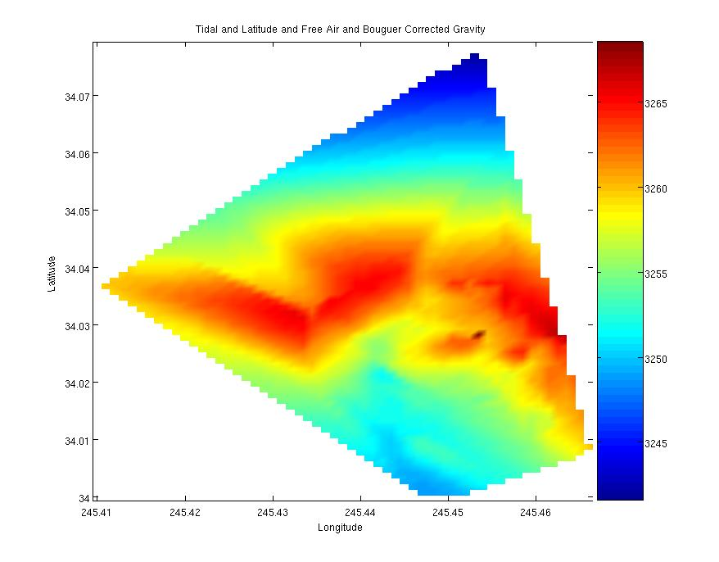
Figure 10: Bouguer corrected gravity

Terrain Correction
The terrain correction accounts for two aspects of the topography on which gravity measurements are taken. When in a valley, the elevated mass to the side of the gravimeter has an upward attraction. This upward attraction decreases the observed gravity. When on the top of a hill or mountain, the sloping mass below the gravimeter has a slight downward attraction, also decreasing the observed gravity.

IV. Analysis
The higher gravity band in the center of the graph corresponds to the higher density preCambrian rocks. The eastern part of the graph also has a higher density region that corresponds to the Paleozoic and Mesozoic to the east of the Eastern detachment fault. The Tertiary has lower gravity which shows less density of rock. Tertiary rocks are mostly sandstones, conglomerates and lake sediments, which are lower densities than the reworked and partially metamorphosed preCambrian rocks. If this area is in isostatic balance, the Tertiary would also be in a thicker layer underground. From geological mapping, the Eastern detachment fault looks very shallow, therefore probably not having a deep basin associated with the Tertiary.

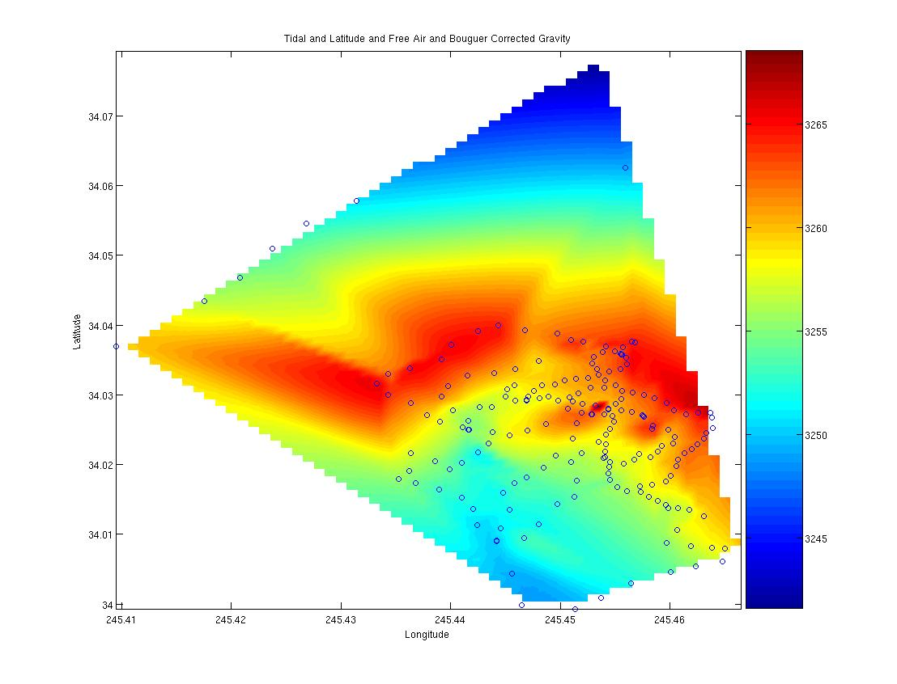
Figure 11: Combined 2004 & 2005 Data Points

Calculating densities of various rock types
Two measurements at the edge of a wash were taken on the first day of hiking. The edge of the wash was composed of alluvium. Taking two measurements of distinct elevation at the edge of the wash enabled the calculation of the density of the alluvium:
$\begin{aligned}gB=k−2πG(Δh)ρ/2 \\ gA=k+2πG(Δh)ρ/2−Δh(0\text{.}\text{307}){\text{mgal}}/m \\ Δg=\text{3233}\text{.}\text{55}−\text{3232}\text{.}\text{16}=1\text{.}\text{39}\text{mgal}=gB−gA \\ 1\text{.}\text{39}=2πG(Δh)ρ−Δh(0\text{.}\text{307}) \\ Δh=6\text{.}\text{96}m \\ 1\text{.}\text{39}=2πG(6\text{.}\text{96})ρ−6\text{.}\text{96}(0\text{.}\text{307}) \\ G=6\text{.}\text{673}×{\text{10}}^{−\text{11}}×(\text{100000000}) \\ ρ=2\text{.}\text{56}g/{{\text{cm}}^{3}}\end{aligned}$

Gravimeter Warm-Up Test
Due to the new inability to transport the gravimeter batteries on airplanes, the gravimeter had to be warmed up starting in the field. Instead of the ideal warm up time of a week, the gravimeter had only 12 hours to reach operational temperature of 47.6°C. The time allotted for battery re-charging was also only 12 hours. This created problems on the last day in the field when the battery voltage dropped below the ideal voltage of 12V. Although the day was completed with the gravimeter maintaining its ideal temperature, a test was done back at MIT to observe the temperature dependence of the dial reading on the gravimeter.
Figure 12: Gravimeter Test

MATLAB Codes

%Data Sets for pure_data.m-Columns
% 1 point name
% 2 year
% 3 day of year
% 4 hour California time
% 5 minute
% 6 minutes past Jan 8, 2005 00:08:00 UT
% 7 gravity dial reading
% 8 height correction (cm)
% 9 latitude degrees North
% 10 longitude degrees East
% 11 absolute height elliptical (m)
%%%%%%%%%%%%%

load pure_data.m;
load crude_data.m;
name=pure_data(:,1);
minutes=pure_data(:,6);
dial=pure_data(:,7);
hcorr=[crude_data(:,8);pure_data(:,8)];
lat=[crude_data(:,9);pure_data(:,9)];
long=[crude_data(:,10);pure_data(:,10)];
height=[crude_data(:,11);pure_data(:,11)];

cname=crude_data(:,1);
cminutes=crude_data(:,6);
cdial=crude_data(:,7);

%Gravity Conversion
%formula derived elsewhere
%%%%%%%%%%%%%%%%%%%
g_dial=dial.*1.0576-6.6959;
cg_dial=cdial.*1.0576-6.6959;
ga_dial=[cg_dial;g_dial];

%Tidal Correction
%%%%%%%%%%%%%%%%%%
load tides.m
Atides=[(tides(:,3)-8).*1440+60.*(-8+tides(:,4))+tides(:,5) tides(:,7)./1000];
plot(Atides(:,1),Atides(:,2))
R=floor((minutes)./5+.5)+1;
g_tide=g_dial-Atides(R,2);

load ctides.m
Btides=[(ctides(:,3)-11).*1440+60.*(-8+ctides(:,4))+ctides(:,5) ctides(:,7)./1000];
plot(Btides(:,1),Btides(:,2))
S=floor((cminutes)./5+.5)+1;
cg_tide=cg_dial-Btides(S,2);
aname=[cname;name];
ga_tide=[cg_tide;g_tide];

%Drift Correction
%%%%%%%%%%%%%%%%%
%extract Base Camp Values from Tidal correction
%fit linear function
%correct ga_tide according to linear function

%Latitude Correction
%%%%%%%%%%%%%%%%%%%%
lat_corr=978032*(1 + 5.2789e-3*(sin(lat*pi/180)).^2 - 2.35e-6*(sin(lat*pi/180)).^4)-978032*(1 + 5.2789e-3*(sin(max(lat)*pi/180)).^2 - 2.35e-6*(sin(max(lat)*pi/180)).^4);
g_lat=[aname ga_tide-lat_corr];

%Free Air Correction
%%%%%%%%%%%%%%%%%%%%
aheight=height-hcorr./100;
g_freeair=[g_lat(:,2)+.307.*(height-min(height))]

%Bouguer Correction
%%%%%%%%%%%%%%%%%%%
b_corr=2*pi*2.57*6.673e-6.*height;
g_boug=[g_freeair(:,2)-b_corr];

%Terrain Correction
%%%%%%%%%%%%%%%%%%%
%get function

%GRAPHING
%%%%%%%%%
[x,y]=meshgrid(min(long):.0001:max(long), min(lat):.0001:max(lat));
z=griddata(long,lat,g_ABC(:,3),x,y,'cubic');
shading interp
pcolor(x,y,z);

Complete Gravity Data [2004/2005]
398 2005 9 8 9 2409 3064.24 155 34.062513490 245.455947957 234.5261
300 2005 9 9 8 2468 3052.21 154 34.037689998 245.456536568 318.5864
301 2005 9 9 25 2485 3049.52 161 34.036960010 245.454166844 329.1656
302 2005 9 9 48 2508 3057.03 157 34.037582271 245.452102272 293.4955
303 2005 9 10 4 2524 3052.19 157 34.037867776 245.450992315 318.0387
304 2005 9 10 15 2535 3056.49 163 34.038769919 245.449708245 296.6910
305 2005 9 10 29 2549 3057.58 158 34.039261417 245.446812833 290.2621
306 2005 9 10 40 2560 3052.48 161 34.039953330 245.444377440 317.7218
307 2005 9 10 54 2574 3050.23 167 34.039181237 245.442492588 326.2248
308 2005 9 11 5 2585 3048.37 163 34.037190879 245.440097307 333.5737
309 2005 9 11 20 2600 3050.06 158 34.035033897 245.439205357 326.0381
310 2005 9 11 34 2614 3047.30 157 34.033812280 245.436265521 336.6247
311 2005 9 11 41 2621 3053.99 157 34.033043138 245.434303289 302.9273
312 2005 9 12 0 2640 3045.46 151 34.031606533 245.433257161 344.1159
313 2005 9 12 15 2655 3050.36 161 34.030001590 245.434331011 320.3288
314 2005 9 12 48 2688 3053.25 157 34.028817933 245.436359403 304.0886
315 2005 9 12 59 2699 3057.27 163 34.027099473 245.437879373 282.2406
316 2005 9 13 12 2712 3059.63 164 34.026192575 245.438996469 268.9596
317 2005 9 13 24 2724 3062.10 163 34.025327465 245.441120398 254.4667
318 2005 9 13 36 2736 3062.46 155 34.025021036 245.441642901 251.7352
319 2005 9 13 47 2747 3063.77 174 34.025043313 245.441709377 244.9804
320 2005 9 14 1 2761 3061.06 151 34.024620406 245.443818658 258.2936
321 2005 9 14 20 2780 3063.58 158 34.026323390 245.441630141 247.3861
322 2005 9 14 34 2794 3061.00 154 34.027805185 245.440214121 262.7658
323 2005 9 14 52 2812 3053.03 169 34.029710822 245.439193763 305.3905
324 2005 9 15 6 2826 3052.95 163 34.031249467 245.439803878 308.4703
325 2005 9 15 25 2845 3053.86 154 34.032810584 245.441537482 305.1351
326 2005 9 15 37 2857 3056.49 166 34.033151226 245.444004577 292.7974
327 2005 9 15 50 2870 3057.08 162 34.033700595 245.445873803 288.7447
328 2005 9 16 1 2881 3058.42 159 34.034884416 245.448021805 281.1332
329 2005 9 16 26 2906 3052.33 163 34.037690600 245.456527915 318.5505
399 2005 9 16 57 2937 3064.51 155 34.062513490 245.455947957 234.5261
602 2005 8 14 25 1345 3059.10 175 34.079484906 245.454115018 230.4597
603 2005 8 14 44 1364 3052.59 115 34.057754673 245.431457058 279.5927
603.1 2005 8 14 57 1377 3051.47 158 34.054523211 245.426856156 287.5884
603.2 2005 8 15 7 1387 3050.32 160 34.050995468 245.423718915 294.3972
603.3 2005 8 15 16 1396 3049.26 162 34.046798783 245.420783209 302.2302
603.4 2005 8 15 31 1411 3048.19 164 34.043462833 245.417518742 308.9389
604 2005 8 15 43 1423 3046.15 140 34.036963884 245.409534260 324.0786
498 2005 11 8 36 5316 3064.67 107 34.062513490 245.455947957 234.5261
400 2005 11 9 19 5359 3059.53 158 34.028025667 245.454354486 276.6360
401 2005 11 9 42 5382 3052.36 153 34.027191569 245.452879778 309.7561
402 2005 11 9 52 5392 3052.12 162 34.025979444 245.451520729 308.6683
403 2005 11 10 4 5404 3052.90 148 34.025783851 245.448702489 301.6027
404 2005 11 10 15 5415 3057.29 144 34.024861308 245.446985537 279.5474
405 2005 11 10 28 5428 3055.66 134 34.024230526 245.445397916 283.3190
406 2005 11 10 41 5441 3058.90 148 34.022986470 245.443442485 265.2391
407 2005 11 11 1 5461 3059.93 152 34.021737686 245.442519597 244.9981
408 2005 11 11 16 5476 3065.20 167 34.020290628 245.441019863 231.3924
409 2005 11 11 26 5486 3060.90 150 34.019361741 245.439948701 250.2138
410 2005 11 11 38 5498 3061.25 137 34.020463535 245.438558455 252.5530
411 2005 11 11 49 5509 3059.36 143 34.021648969 245.436371885 265.4465
412 2005 11 12 7 5527 3060.68 153 34.019033452 245.436216157 254.6845
413 2005 11 12 15 5535 3060.94 160 34.017927541 245.435291823 252.8601
414 2005 11 12 26 5546 3061.87 138 34.017387335 245.436835179 246.2310
415 2005 11 12 36 5556 3063.70 141 34.016406282 245.438927875 234.9377
416 2005 11 13 8 5588 3064.04 157 34.015304977 245.441004469 231.8523
417 2005 11 13 17 5597 3065.70 139 34.013602235 245.442073286 223.4664
418 2005 11 13 30 5610 3068.52 152 34.011365115 245.442457585 209.0050
419 2005 11 13 41 5621 3069.24 136 34.009068122 245.444164815 204.3236
420 2005 11 13 54 5634 3066.94 149 34.010794078 245.444590043 216.9023
421 2005 11 14 5 5645 3065.89 143 34.013525013 245.445409747 223.3297
422 2005 11 14 18 5658 3065.61 157 34.015973087 245.444826352 224.6310
423 2005 11 14 48 5688 3061.76 142 34.017354029 245.445855360 244.5750
424 2005 11 15 0 5700 3062.29 152 34.018175013 245.446916812 243.3730
425 2005 11 15 16 5716 3059.41 133 34.019492308 245.448476222 259.3967
426 2005 11 15 31 5731 3058.08 145 34.021334771 245.449590297 268.4018
427 2005 11 15 45 5745 3057.87 142 34.023773275 245.451142459 277.4771
428 2005 11 16 4 5764 3059.39 151 34.028035824 245.454354379 276.6907
499 2005 11 16 43 5803 3064.59 107 34.062513490 245.455947957 234.5261
500 2005 12 10 7 6847 3065.80 151 34.013717014 245.459849542 239.1750
501 2005 12 10 34 6874 3061.88 167 34.012644704 245.463065761 261.6974
502 2005 12 10 44 6884 3063.71 163 34.010600441 245.460681410 248.5407
503 2005 12 10 53 6893 3066.18 154 34.008714769 245.459700774 232.4108
504 2005 12 11 6 6906 3064.49 165 34.008352420 245.461886690 243.8718
505 2005 12 11 17 6917 3063.17 156 34.008069931 245.463819567 251.7638
506 2005 12 11 30 6930 3062.99 161 34.007956519 245.465035981 253.6762
507 2005 12 11 49 6949 3060.37 165 34.007557678 245.466848294 267.0543
508 2005 12 12 5 6965 3064.22 151 34.006068625 245.464827438 243.3768
509 2005 12 12 17 6977 3066.65 165 34.005354790 245.462393400 229.4760
510 2005 12 12 29 6989 3067.72 151 34.004618793 245.460098812 220.7347
511 2005 12 12 40 7000 3068.90 147 34.002930916 245.456463530 210.4649
512 2005 12 13 16 7036 3069.88 155 34.000880842 245.453711046 200.9776
513 2005 12 13 28 7048 3070.84 147 33.999315299 245.451391902 192.3673
514 2005 12 13 42 7062 3071.70 156 33.999839397 245.446506697 187.9929
515 2005 12 13 58 7078 3070.64 158 34.004301470 245.445617705 195.1619
516 2005 12 14 12 7092 3069.39 158 34.009053130 245.444168900 204.4690
517 2005 12 14 34 7114 3064.28 159 34.009495365 245.446739245 231.5974
518 2005 12 14 44 7124 3067.25 166 34.011413065 245.448038558 217.0085
519 2005 12 14 55 7135 3065.44 147 34.014362668 245.449738240 227.4041
520 2005 12 15 9 7149 3064.61 153 34.015397087 245.451253212 234.7622
521 2005 12 15 21 7161 3064.31 160 34.017693978 245.451534929 239.6058
522 2005 12 15 34 7174 3061.83 153 34.020307302 245.450988209 251.5167
523 2005 12 15 44 7184 3062.45 164 34.021589261 245.451958357 252.5995
524 2005 12 15 55 7195 3062.14 148 34.023258296 245.453468592 259.5484
599 2005 12 16 45 7245 3064.74 107 34.062513490 245.455947957 234.5261
1 2004 11 10 56 1136 3052.72 144 34.037488333 114.543196667 315.8989
2 2004 11 11 7 1147 3054.86 147 34.036860000 114.544300000 304.7219
3 2004 11 11 17 1157 3054.99 148 34.036273333 114.545011667 304.1429
4 2004 11 11 28 1168 3056.03 152 34.036090000 114.546111667 297.3579
5 2004 11 11 38 1178 3056.73 153 34.035425000 114.546941667 294.2749
6 2004 11 11 49 1189 3057.13 149 34.034541667 114.547118333 291.4649
7 2004 11 11 55 1195 3057.08 147 34.033703333 114.546645000 291.9019
8 2004 11 12 1 1201 3057.76 152 34.032876667 114.546508333 287.9879
9 2004 11 12 15 1215 3058.25 153 34.032426667 114.547460000 284.6499
10 2004 11 12 22 1222 3058.24 154 34.032331667 114.548530000 283.1669
11 2004 11 12 30 1230 3058.67 154 34.032045000 114.549611667 280.7309
12 2004 11 12 43 1243 3059.15 156 34.031535000 114.550496667 277.0839
13 2004 11 12 52 1252 3059.52 148 34.031325000 114.551636667 273.5529
14 2004 11 12 59 1259 3059.77 150 34.030616667 114.552418333 270.9359
15 2004 11 13 7 1267 3060.26 151 34.029765000 114.552928333 267.8089
16 2004 11 13 24 1284 3061.27 151 34.029135000 114.553055000 260.3779
17 2004 11 13 54 1314 3061.87 158 34.029200000 114.554125000 259.5379
19 2004 11 14 7 1327 3062.94 177 34.028270000 114.556238333 252.8569
20 2004 11 14 12 1332 3062.85 153 34.028256667 114.557378333 251.1329
21 2004 11 14 24 1344 3062.54 152 34.029800000 114.555015000 257.0559
22 2004 11 14 29 1349 3061.75 145 34.030768333 114.554870000 260.3999
23 2004 11 14 38 1358 3061.51 149 34.031373333 114.554153333 263.7549
25 2004 11 15 5 1385 3061.33 149 34.029255000 114.553078333 260.1759
26 2004 11 15 12 1392 3061.1 156 34.029501667 114.551908333 262.9519
27 2004 11 15 18 1398 3060.95 149 34.029743333 114.551098333 265.5219
28 2004 11 15 23 1403 3060.61 156 34.029185000 114.550215000 267.1239
29 2004 11 15 32 1412 3060.65 150 34.029641667 114.549163333 268.9879
30 2004 11 15 39 1419 3059.05 157 34.030195000 114.548321667 278.3966
31 2004 11 15 46 1426 3058.84 156 34.030995000 114.547248333 280.1289
32 2004 11 15 51 1431 3058.48 151 34.031013333 114.546006667 282.7099
33 2004 11 15 59 1439 3057.89 146 34.031355000 114.544928333 287.2729
34 2004 11 16 7 1447 3057.74 154 34.032038333 114.545875000 287.4869
35 2004 11 16 32 1472 3052.77 144 34.037488333 114.543196667 315.8989
102 2004 13 9 33 3933 3052.9 155 34.037486667 114.543206667 315.7869
103 2004 13 9 55 3955 3058.04 121 34.031396667 114.544940000 287.1869
104 2004 13 10 5 3965 3058.18 113 34.030531667 114.544390000 285.7029
105 2004 13 10 11 3971 3058.79 118 34.029445000 114.544393333 282.4729
106 2004 13 10 21 3981 3059.49 119 34.028656667 114.544968333 277.8079
107 2004 13 10 31 3991 3059.77 123 34.027918333 114.545626667 274.6309
108 2004 13 10 41 4001 3060.87 121 34.027008333 114.545213333 269.2869
109 2004 13 10 48 4008 3060.45 124 34.026105000 114.545088333 272.2039
110 2004 13 10 56 4016 3061.22 122 34.025128333 114.545488333 266.8289
111 2004 13 11 2 4022 3061.74 121 34.024261667 114.545823333 263.0059
112 2004 13 11 12 4032 3061.52 121 34.022871667 114.545806667 263.9409
113 2004 13 11 19 4039 3062.11 131 34.021908333 114.545885000 259.2619
114 2004 13 11 26 4046 3063.06 116 34.020990000 114.546076667 251.9419
115 2004 13 11 32 4052 3063.11 119 34.020996667 114.545928333 252.1569
116 2004 13 11 40 4060 3063.88 125 34.020353333 114.545428333 248.7209
117 2004 13 11 48 4068 3063.22 117 34.020165000 114.544221667 254.3379
118 2004 13 11 58 4078 3064.67 125 34.020686667 114.543260000 248.3619
119 2004 13 12 8 4088 3064.59 121 34.021481667 114.542816667 249.7439
120 2004 13 12 16 4096 3064.28 123 34.021110000 114.541805000 253.1979
121 2004 13 12 22 4102 3063.97 121 34.021860000 114.541141667 255.9529
122 2004 13 13 5 4145 3063.44 128 34.022715000 114.540735000 256.1459
123 2004 13 13 12 4152 3063.1 117 34.022970000 114.539675000 262.5979
124 2004 13 13 19 4159 3062.44 129 34.023973333 114.539581667 265.4599
125 2004 13 13 26 4166 3061.33 123 34.025033333 114.540161667 270.2929
126 2004 13 13 41 4181 3052.9 118 34.025071667 114.541595000 311.5339
127 2004 13 13 51 4191 3055.77 124 34.025625000 114.541551667 299.2499
129 2004 13 14 11 4211 3058.25 124 34.026903333 114.542333333 285.4319
130 2004 13 14 18 4218 3058.82 118 34.027010000 114.542416667 281.9469
131 2004 13 14 24 4224 3059.76 108 34.027090000 114.542478333 276.0629
132 2004 13 14 30 4230 3059.15 112 34.027133333 114.542541667 280.3589
133 2004 13 14 36 4236 3059.06 113 34.027590000 114.543495000 280.2449
134 2004 13 14 43 4243 3059.72 119 34.027746667 114.544458333 275.5639
135 2004 13 14 52 4252 3059.64 115 34.027925000 114.545638333 274.5439
136 2004 13 15 8 4268 3057.77 118 34.032875000 114.546513333 287.5079
137 2004 13 15 14 4274 3056.74 110 34.033296667 114.545546667 293.2019
138 2004 13 15 21 4281 3055.69 119 34.033685000 114.544511667 300.1769
139 2004 13 15 28 4288 3050.99 118 34.034385000 114.543923333 322.7089
140 2004 13 15 38 4298 3054.66 107 34.035320000 114.543991667 304.8199
141 2004 13 15 44 4304 3056.1 117 34.035748333 114.544341667 297.6029
142 2004 13 15 51 4311 3055.24 116 34.035778333 114.544403333 302.2809
143 2004 13 15 58 4318 3055.34 109 34.035938333 114.544473333 302.0459
144 2004 13 16 9 4329 3052.87 167 34.037473333 114.543208333 315.9839
201 2004 14 8 53 5333 3052.9 143 34.037486667 114.543206667 315.7599
202 2004 14 9 10 5350 3059.84 177 34.027965000 114.545643333 275.2299
203 2004 14 9 22 5362 3059.37 147 34.028451667 114.546828333 277.3929
204 2004 14 9 29 5369 3059.2 149 34.028663333 114.547983333 277.5319
205 2004 14 9 35 5375 3059.62 129 34.029031667 114.548846667 274.5699
206 2004 14 9 42 5382 3052.87 140 34.027953333 114.549281667 306.5089
207 2004 14 10 9 5409 3053.89 133 34.027485000 114.548073333 303.6419
208 2004 14 10 12 5412 3052.59 149 34.027213333 114.547135000 308.5719
209 2004 14 10 20 5420 3056.26 156 34.027185000 114.546001667 292.9769
210 2004 14 10 27 5427 3059.8 178 34.027981667 114.545643333 275.3789
211 2004 14 10 40 5440 3064.62 175 34.019720000 114.545518333 246.3479
212 2004 14 10 47 5447 3064.33 166 34.018771667 114.545608333 245.2059
213 2004 14 10 53 5453 3065.73 175 34.017760000 114.545458333 236.1979
214 2004 14 11 0 5460 3065.41 171 34.016743333 114.544820000 240.0339
215 2004 14 11 6 5466 3066.23 178 34.016146667 114.543878333 237.1719
216 2004 14 11 12 5472 3064.46 165 34.016058333 114.542695000 246.6489
217 2004 14 11 19 5479 3064.26 157 34.015385000 114.541885000 248.0569
218 2004 14 11 25 5485 3064.42 118 34.014736667 114.541096667 248.1039
219 2004 14 11 32 5492 3066.74 176 34.014168333 114.540373333 236.4999
220 2004 14 11 39 5499 3065.63 157 34.013796667 114.539238333 241.8929
221 2004 14 11 46 5506 3064.85 150 34.013520000 114.538221667 244.8869
222 2004 14 11 57 5517 3064.13 174 34.016863333 114.542708333 249.4019
223 2004 14 12 4 5524 3063.73 163 34.017093333 114.541595000 253.5129
224 2004 14 12 9 5529 3063.82 177 34.017521667 114.540348333 255.8629
225 2004 14 12 13 5533 3063.04 157 34.018381667 114.539946667 260.1799
226 2004 14 12 18 5538 3061.1 159 34.019745000 114.539393333 273.4449
227 2004 14 12 23 5543 3061.79 150 34.020763333 114.539226667 269.9969
228 2004 14 12 27 5547 3061.11 156 34.021658333 114.538685000 274.9039
229 2004 14 12 34 5554 3060.4 157 34.022176667 114.538035000 278.7909
230 2004 14 12 41 5561 3061.06 170 34.022956667 114.537468333 276.4019
231 2004 14 13 18 5598 3060.39 177 34.023688333 114.536866667 279.4839
232 2004 14 13 29 5609 3058.08 143 34.024525000 114.536690000 293.2399
233 2004 14 13 36 5616 3056.31 144 34.025275000 114.536111667 299.0129
234 2004 14 13 47 5627 3048.02 136 34.026706667 114.536166667 339.6169
235 2004 14 13 53 5633 3050.09 137 34.027466667 114.536290000 331.2579
236 2004 14 14 7 5647 3054.61 143 34.027435000 114.537443333 309.0879
237 2004 14 14 12 5652 3057.91 141 34.027241667 114.538506667 290.5609
238 2004 14 14 23 5663 3056.88 135 34.027815000 114.539641667 295.1369
239 2004 14 14 31 5671 3053.54 126 34.028850000 114.540301667 311.3819
240 2004 14 14 42 5682 3056.98 130 34.029498333 114.541380000 294.0109
241 2004 14 14 50 5690 3056.84 157 34.029940000 114.542345000 293.6159
242 2004 14 14 56 5696 3057.8 148 34.030330000 114.543373333 288.9679
243 2004 14 15 4 5704 3058 138 34.030521667 114.544385000 286.1889
244 2004 14 15 21 5721 3052.83 143 34.037486667 114.543206667 315.7599

